newcastle & hunter region german shepherd dog club inc.

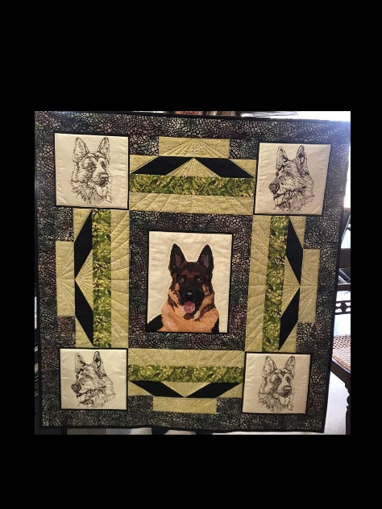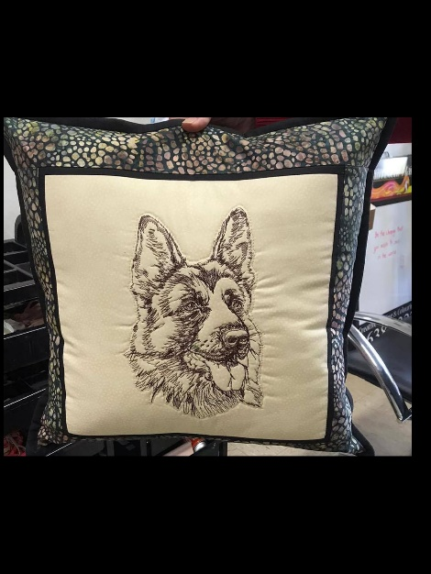

This Quilt is designed, pieced and quilted by Margaret Cormack. Margaret has been a Patchwork & Quilting teacher for many years. She has won many prizes for quilting, including ‘Best of Show’ in the Queensland Quilt Show. Margaret has also worked for many of the patchwork and quilting magazines and has judged at quilt shows.
The quilt is made of 100% cotton fabrics together with cotton wadding.
It is difficult to put a value on the quilt as it is a once only production piece and will not be made again. That being said we have been advised that $900 to $1100 would be a fair appraisal. This is definitely a once in a lifetime opportunity to have something very special.

The Newcastle & Hunter Region German Shepherd Club is very lucky to be able to offer this as the

- First prize in our Raffle.
- Second Prize in our Raffle are 4 bottles of Peterson House “bubbles”.
- The Raffle tickets will be available for purchase through Showmanager ‘Club Activity’

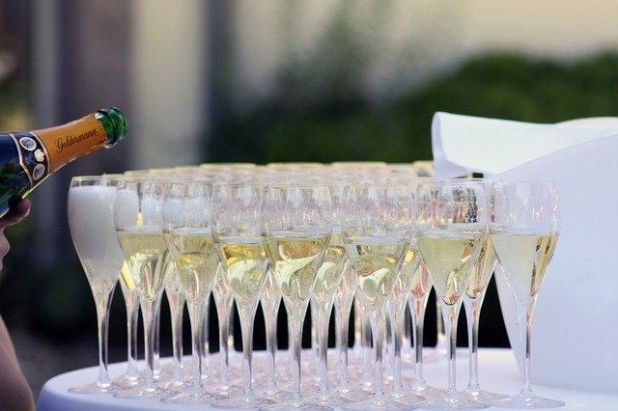
- Cost of the Raffle Tickets are $5.00 each or 3 for $10.00

- The Raffle will be drawn on Sunday the 25th July 2021

